|  |  |
| --- | --- |
| **Subject** | Object Oriented Programming |
| **Assignment 1** | Flight Reservation System |
| **Assignment No. 3 (BSE-B)** | |
| **Submitted By:**  SP24-BSE-005 Abeera Rehman | |  |

**Submitted To:**

|  |  |
| --- | --- |
| **Moderator** | Prof. **Shahid Bhatti** |

**Outputs:**

Initially the FlightDetailsGUI class is complied first:

The user enters the details and if the flight is successfully found then:

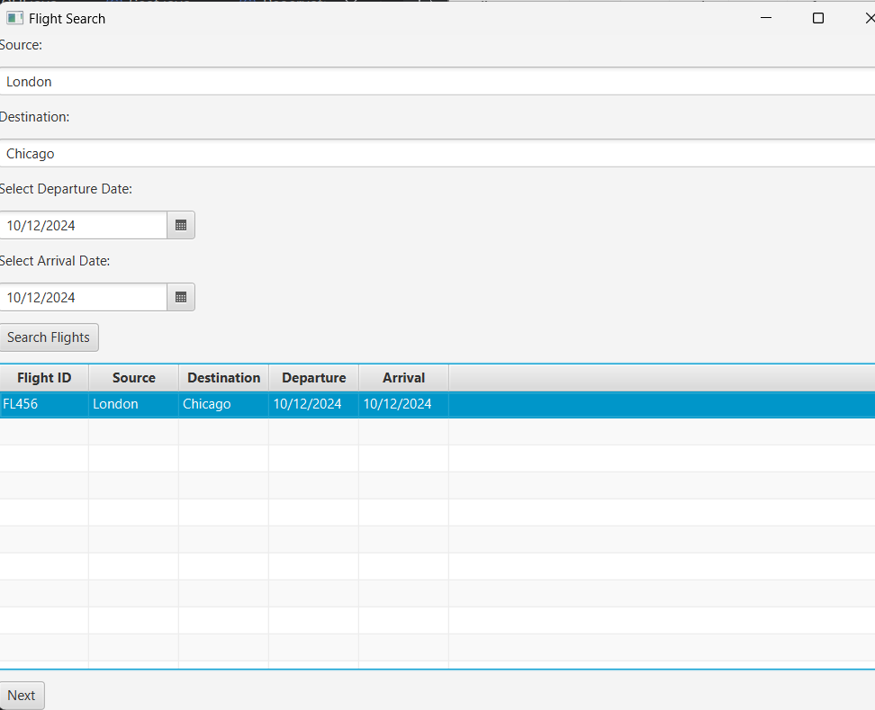

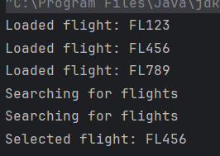

First it asks to select the number of Passengers then displays the form:

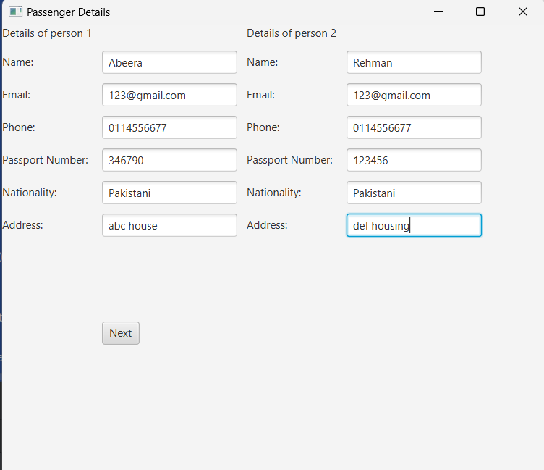

Then it leads to **seatMapGUI** where the passenger will select the seats:

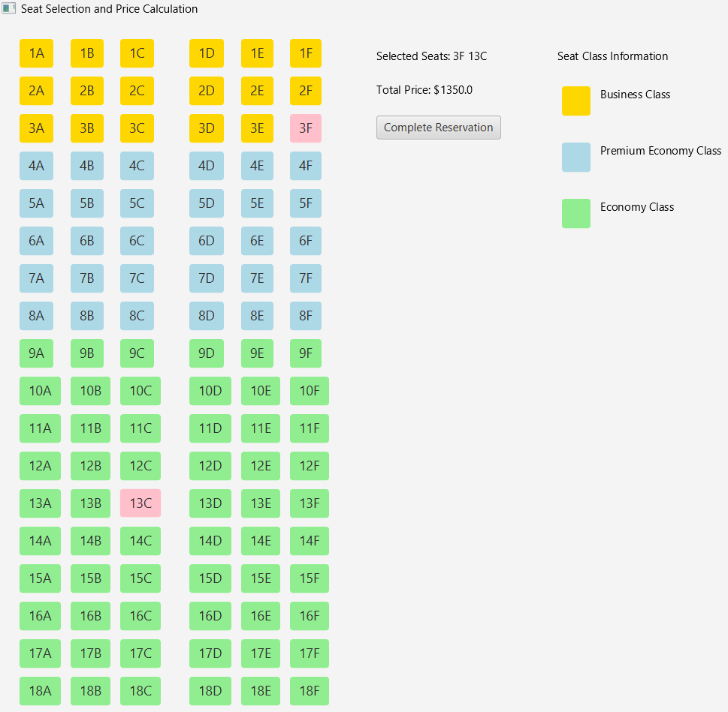

When Complete Reservation button is pressed, **ReservationGUI** is executed:

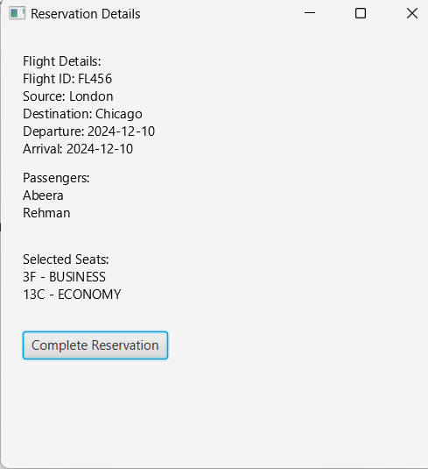

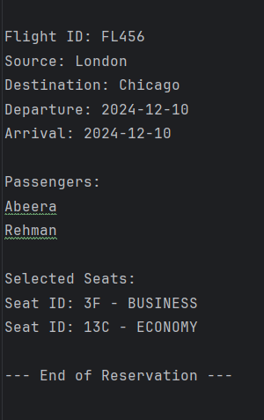Upon successful reservation it will display alert and store it in Allreservation.txt file